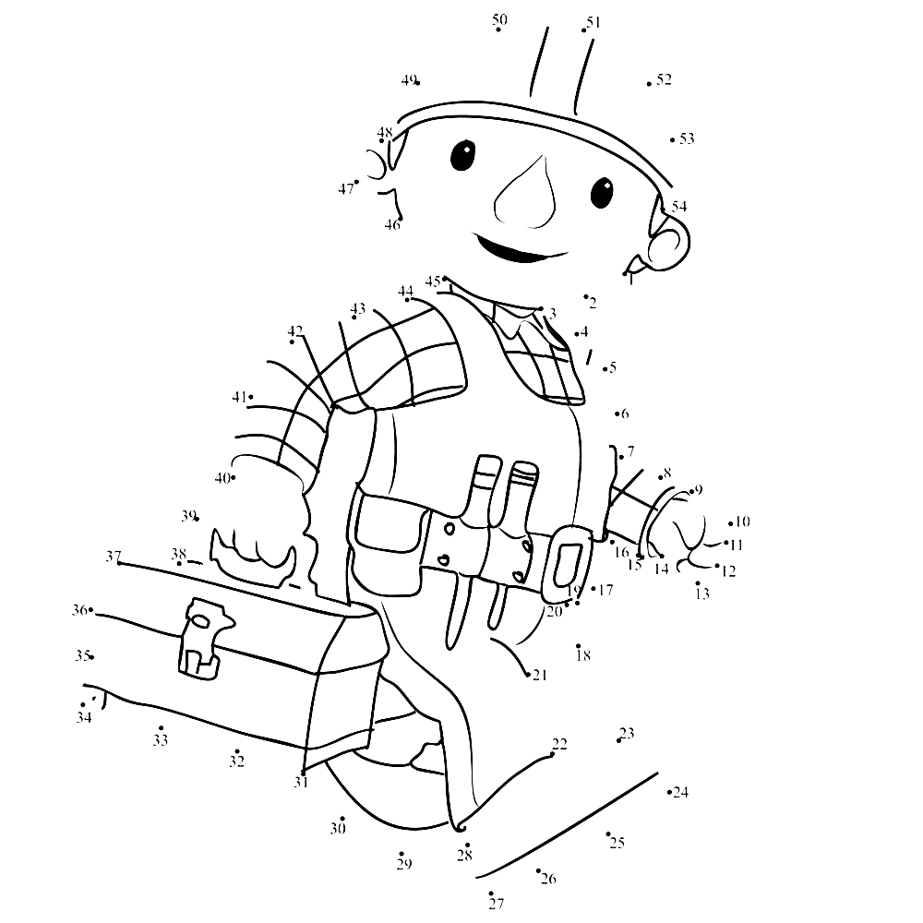
Naam:………………………………………………………………………. Adres:……………………………………………………………
School:………………………………………………………………………. Groep:…………………………………………………………..
Telnr:………………………………………………………………………… E-maill:………………………………………………………….
Victorveiling vrijdag 26 oktober 2018
Thema: onderhouden en verbinden

